Faculty Senate

Academic Programs Committee

Report for March 26, 2024 Senate Meeting

The following proposals need to be reviewed by the Academic Programs Committee.

CLICK (or ENTER) this URL.

https://nextcatalog.utoledo.edu/programadmin/

COPY & PASTE this comma-delimited list into CIM programs search box.

UC-UNIV-BS, UC-UNIV-BA

Disregard anything that does not have FACULTY SENATE PROGRAMS in the workflow.

The full instruction sheet, with images, is still included at the end of this document.

Please send major concerns to the entire committee. Please send minor corrections to me directly. Daniel.compora@utoledo.edu

Individualized Program, BA

Individualized Program, BS

These two programs are being brought forward for a name change. A few other minor changes have been made.

- Changed contact person from Kim Pollauf to Mary Humphrys.

- Removed course:
- AL 3500 | - Fundamentals of Interdisciplinary Research

- I am looking into this discrepancy and will get it corrected as soon as possible. The written hours say 39, but the digits still say 42.

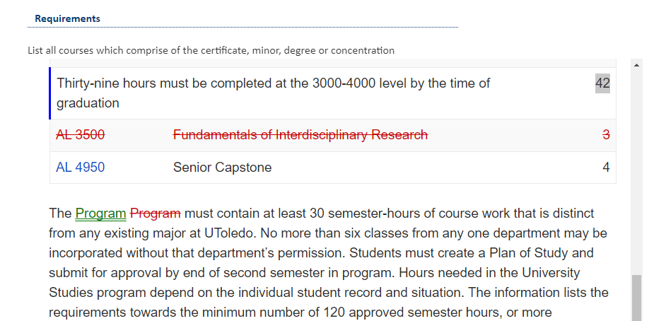

Instructions to View Original Proposal Files on CIM

# NPP New Program Proposal
# PCR Program Change Request

CIM changes summarized: Green is NEW, Red (strikeout) is OLD

ENTER this URL to see the actual proposal documents of programs

https://nextcatalog.utoledo.edu/programadmin/

COPY & PASTE the comma-delimited list into CIM programs search box.

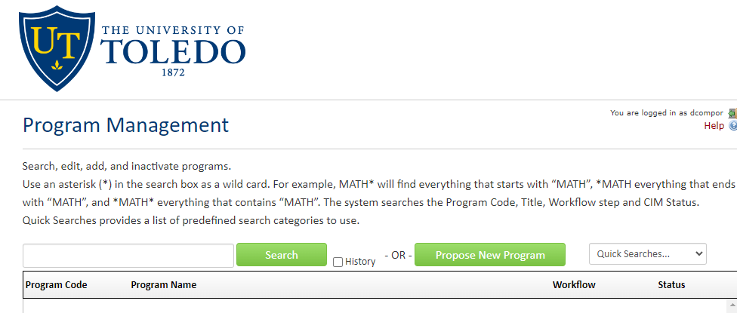

CLICK the Green Search Button, which pulls up all listed proposals in alphabetical order.

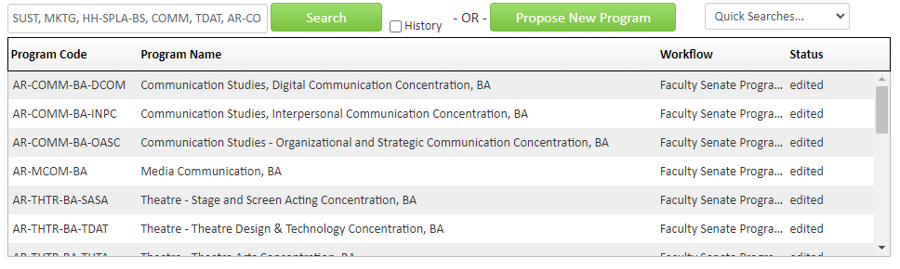
Only items that have Faculty Senate Programs under the Workflow tab have been endorsed by the committee.

SELECT A proposal to view. The list of proposals will remain at the top of the browser page.

