Rectangle 


**The University of Toledo**

**Department of Music Presents**

**The University of Toledo**

**Department of Music Presents**

Song Title Composer

Birth Year/Death Year

*Soloists/Note*

Song Title Composer

Birth Year/Death Year

*Soloists/Note*

Song Title Composer

Birth Year/Death Year

*Soloists/Note*

Song Title Composer

Birth Year/Death Year

*Soloists/Note*

Song Title Composer

Birth Year/Death Year

*Soloists/Note*

Song Title Composer

Birth Year/Death Year

*Soloists/Note*

Song Title Composer

Birth Year/Death Year

*Soloists/Note*

Song Title Composer

Birth Year/Death Year

*Soloists/Note*

Song Title Composer

Birth Year/Death Year

*Soloists/Note*

Song Title Composer

Birth Year/Death Year

*Soloists/Note*

Concert Title

Ensemble or Performer Name

Month 00, 2021 at 0 p.m.

Building Name - Space Name

Concert Title

Ensemble or Performer Name

Month 00, 2021 at 0 p.m.

Building Name - Space Name

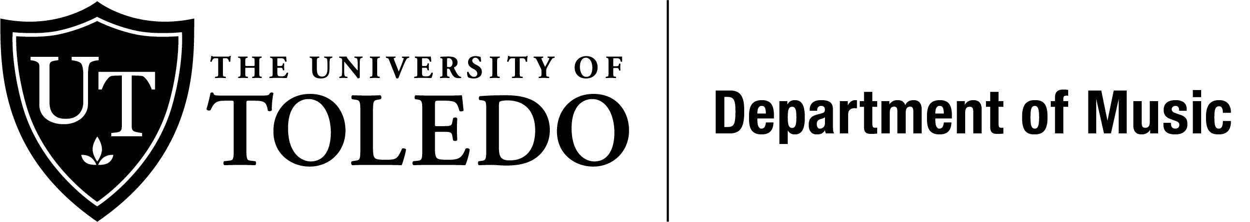

Song Title Composer

Birth Year/Death Year

*Soloists/Note*

To add songs, just copy and paste the 3 lines above together and click paste.

Add program notes or acknowledgements here. If there are no songs or text for this page, delete this text box/frame. To delete the box, click on the box and when the box is selected, click delete. The logo will remain.



Song Title Composer

Birth Year/Death Year

*Soloists/Note*

To add songs, just copy and paste the 3 lines above together and click paste.

Add program notes or acknowledgements here. If there are no songs or text for this page, delete this text box/frame. To delete the box, click on the box and when the box is selected, click delete. The logo will remain.

