Process for New Graduate Program Development
University of Toledo
College of Graduate Studies
October 23, 2019 Version

It is advised that when the development of a new program is under consideration by an academic unit that the College of Graduate Studies (Associate Dean or Dean) is notified. This initial notification will allow the College of Graduate Studies to assist in program development and to inform the unit of any barriers that may exist concerning the program proposal. Also, it may be possible to provide helpful examples.

General Overview
The development, approval, and launch of any new graduate program shall be carried out in accordance with the University of Toledo New Graduate Program Approval Process http://www.utoledo.edu/offices/provost/program-development/. In addition, it is necessary to consider the Ohio Department of Higher Education – Chancellor’s Council on Graduate Studies (CCGS) Guidelines and Procedures for Review and Approval of Graduate Degree Programs.
https://www.ohiohighered.org/sites/default/files/CCGS%20Guidelines%20-%20revised%20March%202019%20final.pdf

Overall New Program Review Process

The new program approval process includes steps outside of the University curriculum management system (CIM) with no signature, inside CIM that generate electronic signatures, and outside of CIM that generate approvals needed for signature (Figure 1). During this process, presentations of the proposed program are required before Graduate Council, Provost (and likely President), Board of Trustees, and CCGS.

Please note, successful generation and review of the new program concept through the stage of Graduate Council approval is followed by (or completed in parallel with) the development of a Full Proposal and Fiscal Impact Statement by the Graduate Program in accordance with CCGS guidelines (proposal submission template and fiscal impact statement available from COGS). Once drafted, the Full Proposal and Fiscal Impact Statement will be reviewed by COGs and the Provost’s Office before submission and final approval at CCGS. The entire process from program concept to program launch is likely to take 12 to 18 months.

Feedback received through the approval process should be integrated into the document after each stage of review. The VP for Finance will act in an advisory role to the Provost to to ascertain the support needed by the proposed program from the University and to determine the financial viability of the proposed program.

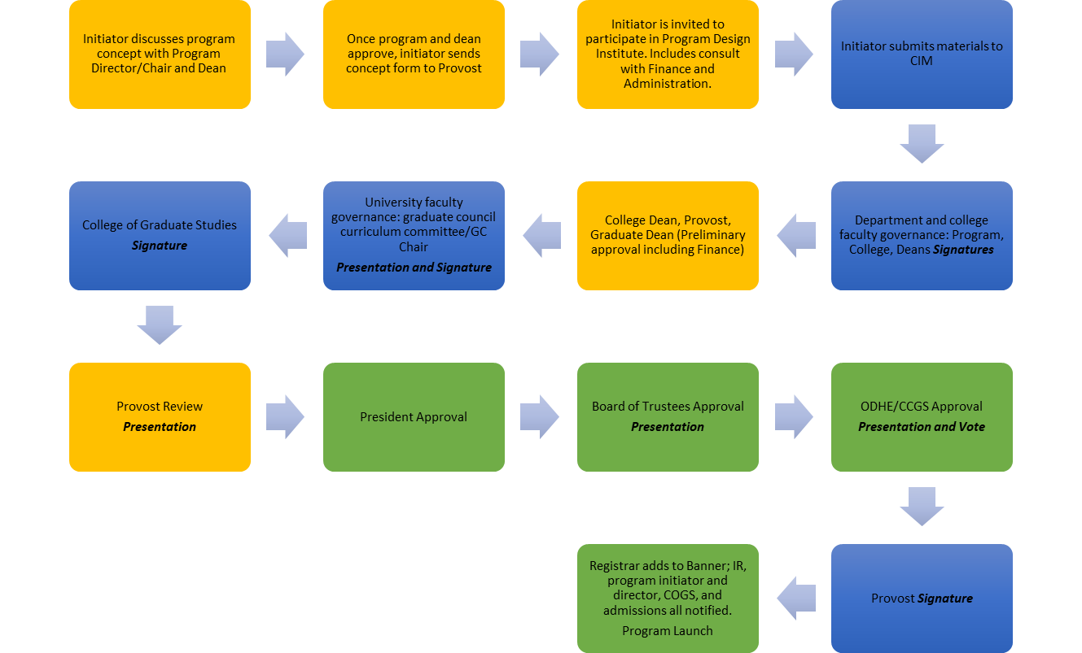

Figure 1: New Graduate Program Approval Process
STEPS:
Program Concept discussed with Program Director/Chair and Dean
Send Program Concept to Provost
Participate in program design institute
Submit materials to CIM
Department and College Faculty Governance Review
College Dean/Porvost/Graduate Dean preliminary approval
Graduate Council Curriculum Committee Review (presentation)
College of Graduate Studies Approval (full proposal required)
Provost Review (presentation)
President Approval
Board of Trustees Approval (presentation)
ODHE/CCGS Approval (full proposal, fiscal impact statement, presentation
Provost Signature
New Program Added to Banner and Launched

Full Proposal (FP) for CCGS Review
The Full Proposal required by CCGS for a new degree or degree programs overlaps with the Substantive Change Application from the Higher Learning Commission. The CCGS Guidelines and Procedures Manual outlines the specific requirements for a Full Proposal and includes a template for the Full Proposal.

When the full proposal is submitted to the provost office for review, the proposer should be prepared to deliver a brief Powerpoint presentation to the provost/provost designee and members of his/her staff. The Provost will take his/her recommendations to the President and, after positive review by the President, an executive summary of the program proposal will be provided to the Board of Trustees prior to their next meeting for approval. A similar brief Powerpoint presentation will be delivered to the Academic Affairs Committee of the Board of Trustees for approval.

When the FP has been approved at all levels at the insitition including the Board of Trustees, it will be reviewed by member institutions in accordance with CCGS guidelines. Feedback will be provided by member institutions. Before a proposal at CCGS can be scheduled, a response document and an updated Full Proposal incorporating all feedback must be submitted to CCGS. A brief (10 minute) Powerpoint presentation will be given by the team of individuals from the proposing program, department, and/or college at a regularly scheduled meeting of the CCGS. This process results in a formal vote and recommendation to the Chancellor who has the ultimate authority to grant or deny an institution the right to offer a new degree. Programs may not advertise or recruit for programs that have not received Chancellor’s written letter approval (usually six weeks following the presentation and vote at the CCGS meeting in Columbus).

Presentation Guidelines
Please use the University of Toledo presentation template for preparing your new program proposal presentation. Access it here: http://www.utoledo.edu/offices/marketing/toolkit/

Your presentation includes an overview of the key components of your Full Proosal and your fiscal impact statement. Please note that CCGS limits presentations strictly to 10 minutes.

Fiscal Impact Statement (https://www.ohiohighered.org/ccgs)
Budget for New Graduate Degree Programs

 | Year 1 | Year 2 | Year 3 | Year 4
Projected Enrollment
Head-count full time
Head-count part time
Full Time Equivalent (FTE) enrollment
Projected Program Income
Tuition (paid by student or sponsor)
Externally funded stipends, as applicable
Expected state subsidy
Other income (if applicable, describe in narrative section below)
TOTAL PROJECTED PROGRAM INCOME:
Program Expenses
New Personnel
- Faculty (e.g. tenure-track, clinical, professional)
Full ____
Part Time ____
- Non-instruction (indicate role(s) in narrative section below)
Full ____
Part time ____

New facilities/building/space renovation
(if applicable, describe in narrative section below)
Tuition Scholarship Support
(if applicable, describe in narrative section below)
Stipend Support
(if applicable, describe in narrative section below)
Additional library resources
(if applicable, describe in narrative section below)
Additional technology or equipment needs
(if applicable, describe in narrative section below)
Other expenses (e.g., Waived Tuition and Fees, travel, office supplies, accreditation costs) (if applicable, describe in narrative section below)
TOTAL PROJECTED EXPENSE:
NET

Budget Narrative:

