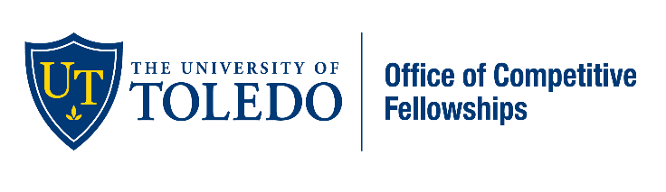Boren Scholarship
Awards up to 20,000 for a study abroad language acquisition outside of Western Europe, Canada, Australia, or New Zealand. Year to apply: Years 1-4 Deadline: February
Critical Language Scholarship
Awards all program costs for students interested in undertaking the intensive study of a critical language including, but not limited to Chinese, Arabic, and Hindi. Year to apply: Years 1-4 Deadline: November
Fulbright
Awards funding for a one-year postgraduate study/research/teaching assistant experience. Year to apply: Years 3-Alumni Deadline: Early October
Gates-Cambridge
A highly prestigious award that supports a postgraduate degree earned at Cambridge University in the United Kingdom. Year to apply: Years Three-Alumni Deadline: Early October
Benjamin A. Gilman
Awards up to 5,000 to students of limited financial means to study or intern abroad. Applicant must be receiving a federal Pell Grant. Year to apply: Years 1-4 Deadline: 1st Tuesday in October and March
Barry Goldwater
Awards undergraduates up to $7500 for both junior and senior years. Students must be majoring in natural sciences, engineering, or mathematics and wish to pursue research careers in these fields. Year to apply: Year 3-4 Deadline: Last Friday in January
National Oceanic and Atmospheric Ernest F. Hollings Scholarship
Awards undergraduate applicants up to $9,500 per year for two years of study and $700/week for a 10-week summer internship at a NOAA facility. Year to apply: Years 2-3 Deadline: Late January
James Madison Scholarship
Awards up to $24,000 prorated over the period of study. Applicants must have a desire to become outstanding teachers of the American Constitution at the secondary school level. Years 1-4 Deadline: March 1
Marshall Scholarship
Awards students of high ability to study for a degree in the United Kingdom. Up to forty Scholars are selected each year to study at graduate level at an UK institution in any field of study. Years to apply: Years 3-Alumni Deadline: October 1
George J. Mitchell Scholarship
Awards a monthly stipend to pursue one year of graduate study in Ireland. Years to apply: Years 3-Alumni Deadline: Late September
Charles B. Rangel International Affairs Fellowship
Awards up to $37,000 per year towards graduate school to prepare outstanding young people for careers as Foreign Service Officers in the U.S. Year to apply: Senior-Alumni Deadline: September
Rhodes Scholarship
International post-graduate awards for students to study at the University of Oxford young leaders of outstanding intellect and character. Year to apply: Years 3-Alumni Deadline: First Wednesday in October
Tilman Scholars
Awards military veterans and spouses up to $10,000 per academic year who reflect a proven track record of leadership, pursuit of education and commitment to service beyond self. Year to apply: Years 1-4 Deadline: February
Harry S. Truman Scholarship
Truman scholars receive up to $30,000 for graduate school. Scholars must demonstrate superior leadership as well as a commitment to public service. Year to apply: Junior Deadline: First Tuesday of February
Udall Scholarship
Awards up to $7,000 for educational expenses to students who demonstrate leadership, public service, and commitment to uses related to Native American nations or the environment Year to apply: Year 3 or 4 Deadline: Early March

