How to Create an Amendment in IRB Manager
March 2019

Table of Contents
Overview 1
How to start a Study Amendment 2
How to complete the Amendment xForm 4
How to update an attached file 4
Replacing a file 4
Removing a file 6
Adding a new file 6
Saving your Amendment for later 7
How to find an un-submitted amendment application 8
Option 1: From your dashboard 8
Option 2: From the Study 8
How to Submit the Amendment 9
What happens next 10

Overview
There are two kinds of Amendments in IRB Manager.

- The Simple Personnel Amendment (SPA) is intended to allow you to update the personnel, other than the PI on your study. There is a video on the IRB Manager Rollout page here: http://www.utoledo.edu/research/rsp/irbmanager.html which details the steps for creating and submitting a SPA. SPAs do NOT allow you to change the PI, and if the study’s consent forms name personnel who may explain and/or obtain consent, only those names may be changed on the consent forms submitted with the SPA, no other changes can be accepted.

- The Study Amendment is intended to capture any other changes that need to be made to the research procedures, methods, protocol or documentation, including change of PI. This document describes the process for creating and submitting a Study Amendment.

IMPORTANT NOTE: A Study Amendment can only be created for a Study that has been approved, where the Initial Submission Application is complete. Initial Submissions that are not yet complete, (e.g. under review or waiting for final approval signatures) cannot be copied for amendment.

How to start a Study Amendment
Study Amendments are started from within the study that you will be amending. To find the study from your home dashboard you can either scroll to the bottom of the page and look at “My Studies (Active),” or you can click on the first link in the middle “Studies” section.
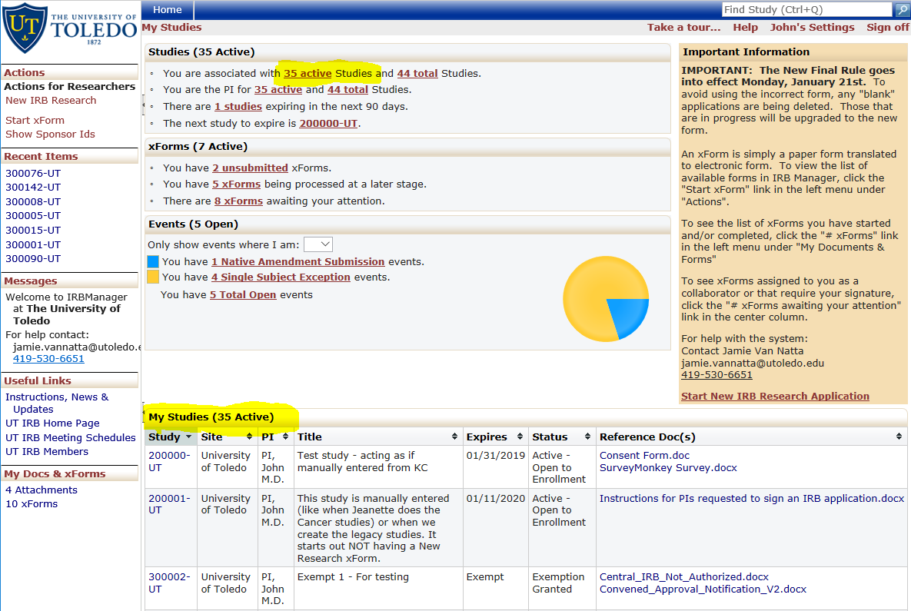
- In either case, click the numbered link “######-**” to enter the study record.
- Once in the study, you should see a page that looks like this:
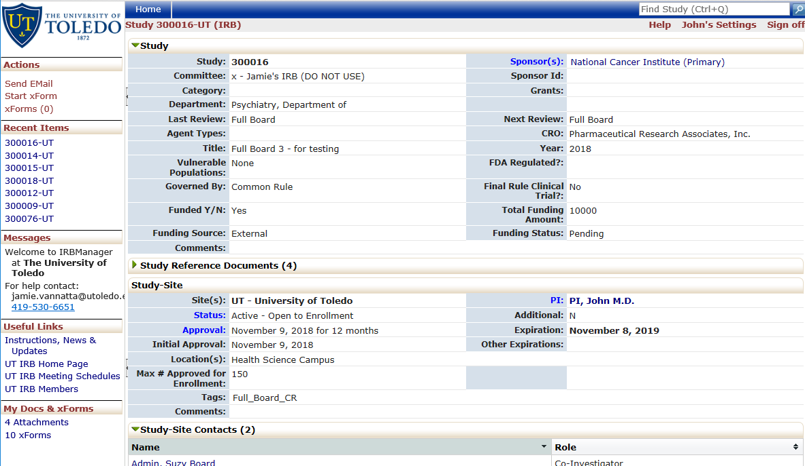

- Scroll down until you see a section called “Reference x-Forms” This should be between “Study-Site Contacts” and “Study-Site Attachments” as below:
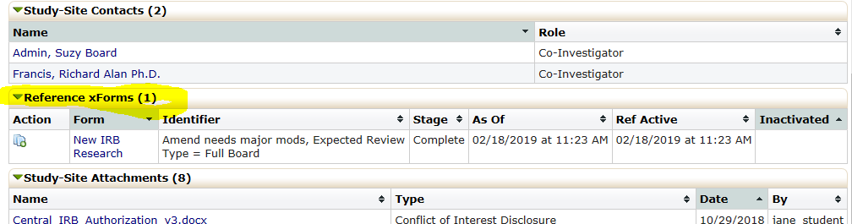

- If you don’t see this section, contact your IRB Staff member for assistance.
- Click the “copy” icon to the far left of the “New IRB Research” form line.
- You will be presented with a choice of what kind of copy you want to make.
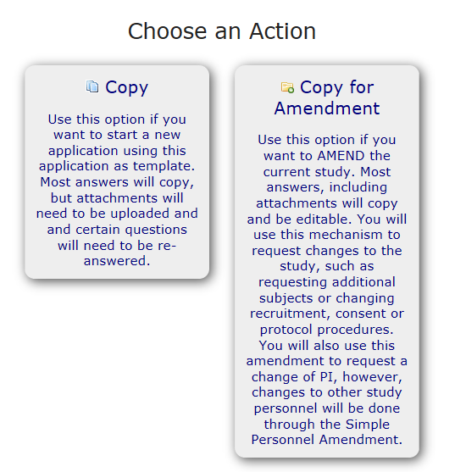

- Choose the right option called “Copy for Amendment”
- This will create and open a new form that will be a copy of the currently approved submission. The first page will contain information about the study you are amending and will allow you to describe what changes you are requesting to be made to your research.

How to complete the Amendment xForm
With the exception of the Personnel Page, all pages of the application will be open for you to amend.

- Complete the first page which summarizes your changes and the reasons for them for the reviewer.
- The first question regarding the amendment reason is defaulted for you. You should not change it unless you have been told to do so by the IRB Staff.
- After summarizing the changes, you must go to the appropriate page of the application and make the change. For example, if you are requesting more subjects, you must not only answer the first page summary question, but also go to the Human Research Subjects page and change the number there. If you are changing recruitment or consent processes or materials, you must update the appropriate page with the new processes and materials.

How to update an attached file
IMPORTANT NOTE: When requesting changes to an attached file (e.g Consent Form, Protocol Narrative, or Recruitment materials), please use the “Replace” function where possible, rather than delete and re-add the file.

IMPORTANT NOTE: Other actions taken this study, such as Simple Personnel Amendments and Adverse Events may have altered some attachments OUTSIDE of the original application. Always make sure that you are submitting the most updated version of the file, including all previous changes when you submit the amendment, even if the amendment itself does not request any changes to that file.

Replacing a file
- If you are updating an existing approved document, click the green circular arrow icon.

- A popup will appear:
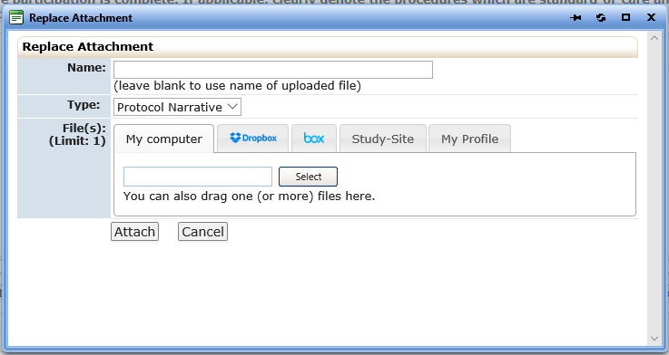

Path A – Uploading a new file with all previous changes included.
- If the file to upload is on your local machine or on the H: or Z: drives, leave the tab as “My Computer”
- Click the “Select” button which opens the standard file dialog box similar to this:
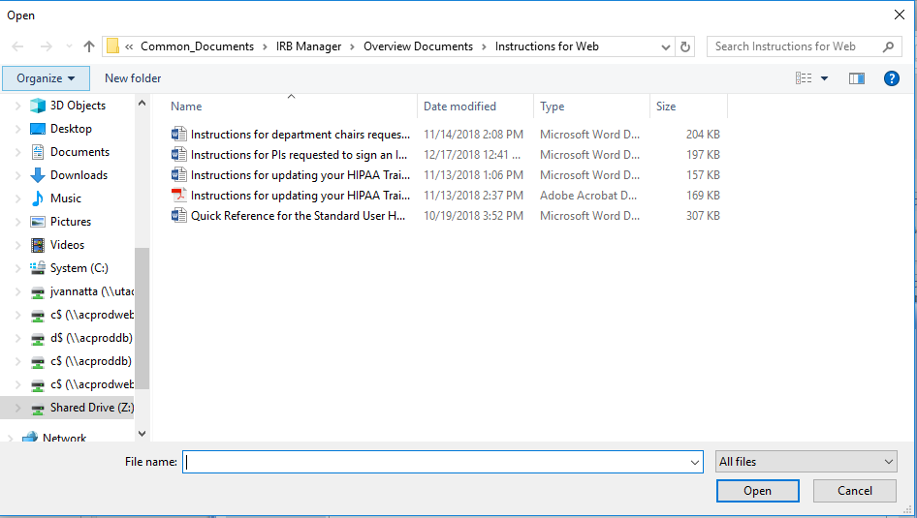

- Select the desired replacement file and click “Open”
- This will bring the file into the IRB Manager file box:
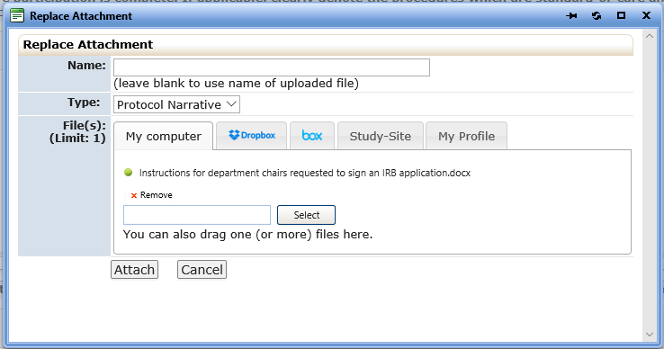
- Click the “Attach” button. This will replace the previous file with the new file.

Path B – The correct updated file is already on the Study-Site from a previous action
- Click the “Study-Site” tab.
- A list of the current Study-Site attached files is presented.
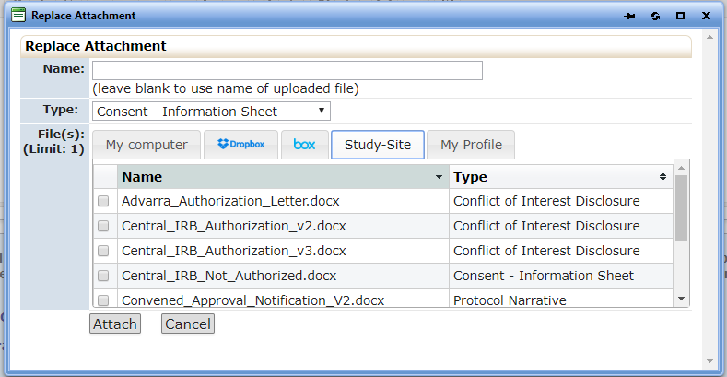
- Click the checkbox next to the file you wish to use as the replacement file. Note, the system allows you to select more than one file, but it will only use the first checked file. Since this is a replacement, select only one file.
- Click the “Attach” button. This will replace the previous file with the new file.

Removing a file
If you wish to remove a file from the study, use the red “x” icon.

Adding a new file
If the question allows multiple files to be attached, there will be an “Add Attachment” button.

- Click the “Add Attachment” button
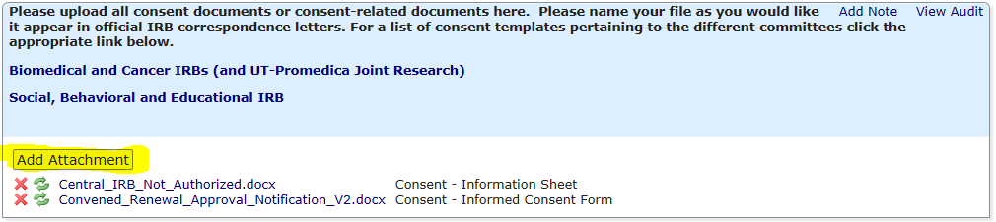

- A popup will appear.
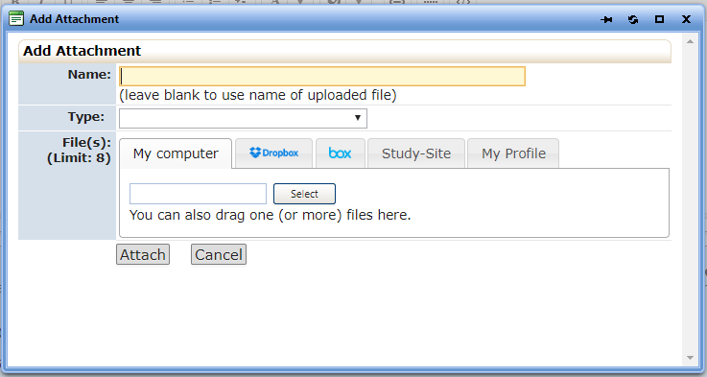

- Follow the instructions for “Replacing a File” following Path A or Path B as appropriate.
Note: Because you are adding, not replacing, you can, if the question allows, upload more than one file at a time per Type.

Saving your Amendment for later
Often you start an amendment but will not finish it in one session. To save your amendment at any time, scroll to the bottom of any screen and click the “Save for Later” button:
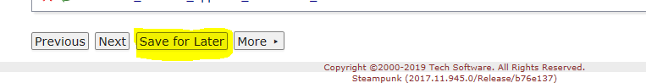

You will receive a confirmation message that your application has been saved:
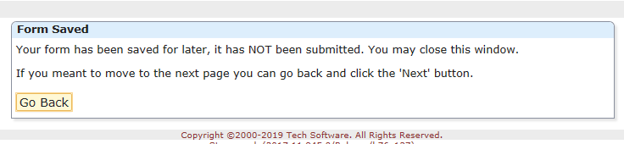

If you accidentally clicked save, you can now click the “go back” button to return to your form.

Note: Your application is saved every time you click “Next” to go to the next page or use the drop-down page selection at the top of the screen. You do not have to use the “Save for Later” button unless you are finished working on the application for a while.

How to find an un-submitted amendment application

Option 1: From your dashboard
Under the xForms heading in the main section of your dashboard, you can access all unsubmitted xforms by click the highlighted link.
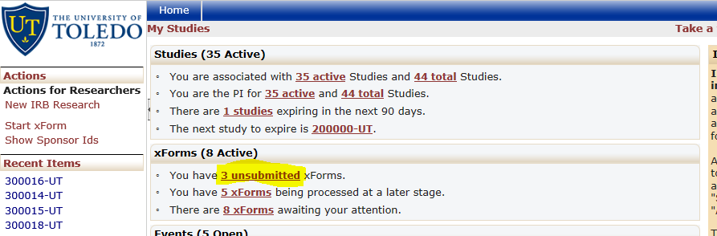

This will take you to a list of the forms
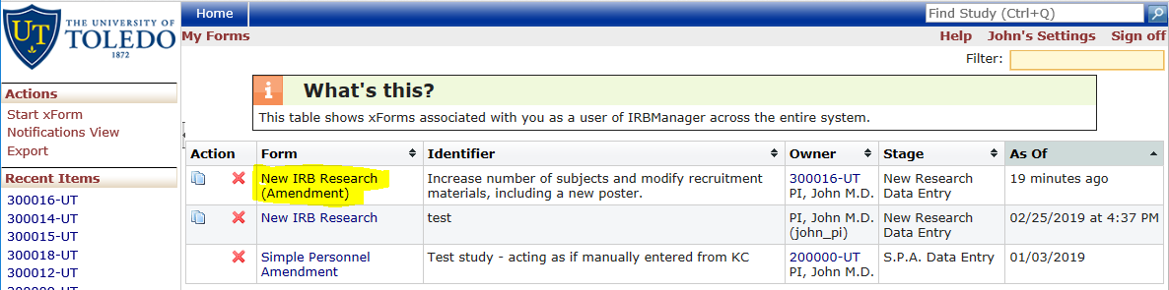
You will notice that the amendment application is denoted as such, shown highlighted here. The identifier column will contain the brief amendment summary you entered on the first page of your amendment. Additionally, the “owner” column identifies the study and PI that the amendment belongs to. Click the Form name link to open the form

Option 2: From the Study
If you are already inside the Study you were amending you can find the amendment application in the list of xForms for the study that do not belong to events yet.

Click the “xforms(#)” link in the Actions menu of the study.
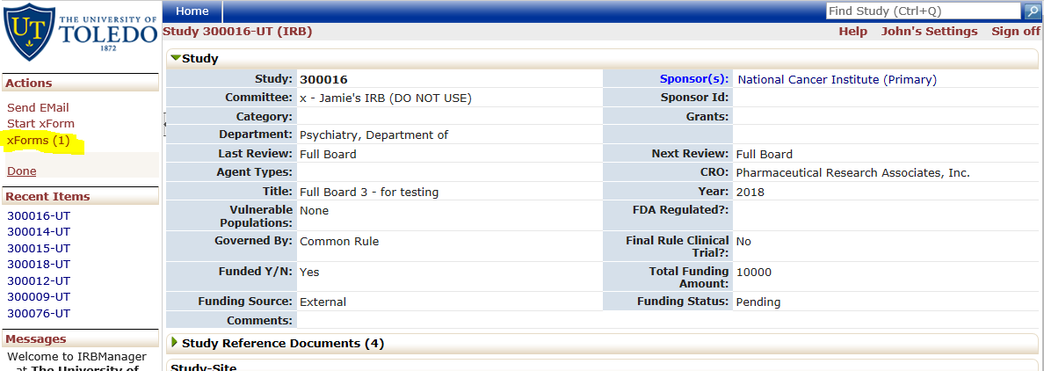
This will take you to a list similar to the above. Again, click on the Form name link to open the form.

How to Submit the Amendment
When you have completed the summary page and the changes to the application pages, you can use the top drop down list to go to the validation check by clicking “Check & Submit Form.” If you have missed any required questions along the way, you will get a message similar to the image below:
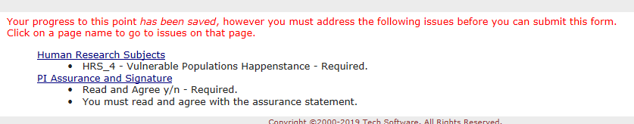

Each blue link is a page name where there is a required question that you did not answer. You can click on the link to take you directly to that page and the required question will be highlighted.

- If you have not missed any required questions, you will be presented with the signature page
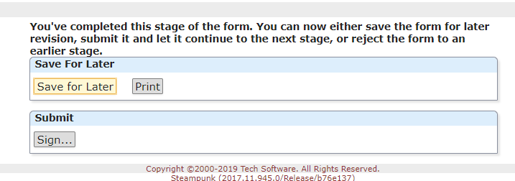
IMPORTANT NOTE: Depending on the stage, this page may have additional options for the PI.

- Click the “Sign” Button.
- This will popup the UT Bell Tower sign in page.
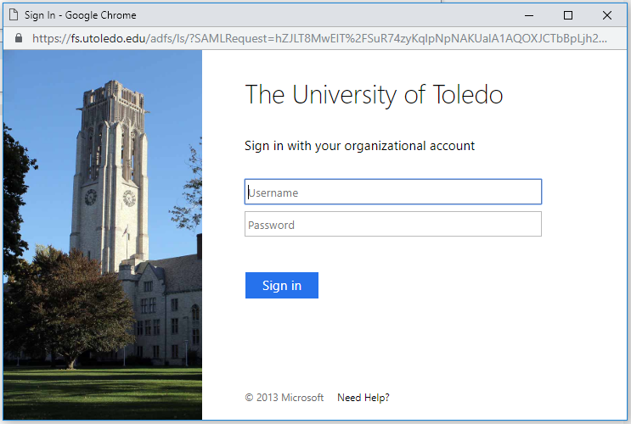

- Type in your UTAD username and password and click the “Sign In” button.
- All done. You will receive a message similar to this:
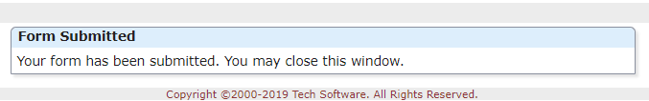

What happens next
- You will receive an email that your PI has been notified to sign the application, unless you are the PI, in which case, you will not have to sign again.
  - If the Amendment is to change the PI, both the current and the new PI will be asked to sign.
- Once the appropriate PIs have signed, you will receive an email that the amendment application has been received in the IRB office.
- The amendment application will be pre-reviewed and either returned to you and the PI for changes or assigned to a reviewer.
- Depending on the type of review, you may receive an email that the amendment application is waiting for the next Full Board meeting to review.

Further steps depend on the review outcome and/or board meeting decision. You can see what stage your application is in at any time from your dashboard by clicking the “# xforms being processed at a later stage” link.
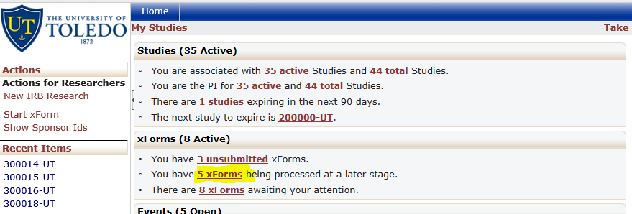

If your amendment application is returned for revisions, either after Pre-Review, Review or Full Board Review, you will receive an email. The amendment application will be a link in the email, but can also be found on your dashboard under the “# xForms awaiting your attention” link.
